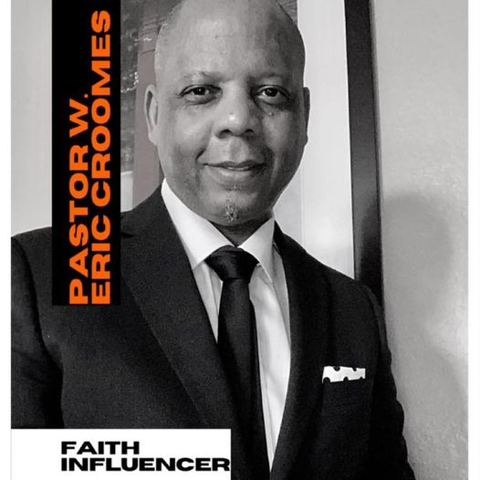
Go all the way up with the Believers Impact Coach, Pastor W. Eric Croomes!
Insightful and inspirational faith commentary for spiritual empowerment.

Pastor W. Eric Croomes is a faith influencer who values dedication, service and excellence. As a ministry leader and coach for close to four decades, Pastor “C” brings a unique, holistic perspective to your organization or live church event. Pastor C uses biblical perspective, positive anecdotes, and affirmation to empower his audience to unleash their purpose for a purpose. Pastor C unveils how each person in the life of your organization brings a wealth of potential that can be used toward positive results.
A native of Phoenix, Arizona, Pastor C learned the value of dedication and service coming up as the third of six children whose parents, the Reverends Charley and Dorothy Croomes, were themselves exemplar models for ministry. Pastor C founded and is chief executive officer of The Charley and Dorothy Croomes Foundation, launched in 2022 in his parent’s honor. He is also founder and executive pastor of Pastor W. Eric Croomes Ministries.
Pastor C is author of Watch Your Life: The Believer’s Guide to Thinking, Speaking and Acting Confidently in a Belief-Challenged World and Surge into the New: Stand Up Reach God’s Excellence, a book aimed at helping Christian believers strengthen their faith walk in Christ, written in the middle of a pandemic.
Two of Pastor C’s books, Dance in the Dark, Poetic Reflections on Love and Culture (The Apple Tree Group, 2002) and Brotha2Brotha, Becoming Healthy Men from the Inside Out (The Apple Tree Group, 2006), were nominated in 2007 for a literary award for treatment of relationships, personal achievement and spiritual empowerment.
Pastor C earned a Bachelor of Arts in religion and sociology from Jarvis Christian College in Hawkins, Texas in 1990 and has matriculated at Perkins School of Theology in Dallas, Texas and Southwestern Baptist Theological Seminary in Fort Worth, Texas.
Press Contact:
Pastor W. Eric Croomes
PWEC Media Group
info@pastorwericcroomes.com
214.493.2875

