# Fitness – Nutrition - Detox

*ISC 2022*

Infinite Strategies Coaching (IFC) 14-Day Tummy

14-Day Lifestyle Exercise Program *Fitness by Eric*

## **Your best body**

## **IS**

## **Your best Life!**

## **\***

## **Transformation Coach**

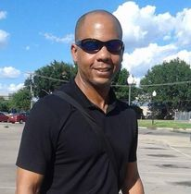

## **You don’t need time - you just need 15 minutes!**

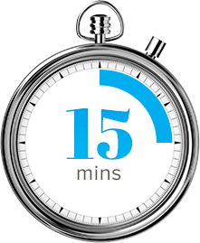

## **W. Eric Croomes**

## 214.493.2875

## Online at:

## [www.pastorwericcroomes.com](http://www.pastorwericcroomes.com)

**Mission:**

To deliver training results my clients will love!

**\***

**Vision:**

Infinite Fitness Coaching will become the world-class leader in mind-body fitness**.**

### **Overview**

Losing your tummy is more than doing sit-ups. It’s a comprehensive approach like my *14-Day Tummy Shaper*! *14-Day tummy* combines workout with nutrition and detox for maximum results! Participants in this program lose an average of 6-9lbs and drop body fat by 3-5%. Participants also experience increased energy. The best results are overall toning and shaping of the midsection.

The nutrition component includes a natural detox, customized meal plans for diabetes, blood pressure etc. for managing and/or reversal of those chronic illnesses. Also, we have now included plant-food based nutrition protocols!

We’ll begin with a fitness assessment/workout to establish your baseline. You will then complete an online lifestyle questionnaire in order for us to design the most customized, efficient, effective and safest workout prescription. Let’s get started!

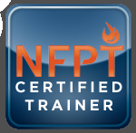 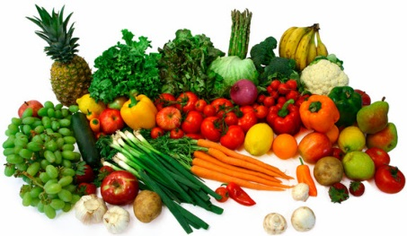****

National Federation of Professional Trainers

**BLAST FAT. BUILD MUSCLE.**

**You will need to do five things for 14 days:**

**1. Drink water**

**2. Follow the customized meal schedule**

**3. Complete assigned home ab workouts**

**4. Meet online or in person 4x**

**5. Be AWESOME!**

**Get the tummy of your dreams! Lose inches around your waist and reduce body fat!**

**Meet**

**Eric Croomes**

Hi! My name is Eric Croomes and I **love** what I do! I am a Holistic Lifestyle Exercise Expert and author.

I believe that when you build your best body, you build your best life. I take great pride in delivering the training protocol you will love and the results you need!

**Let’s get started!**

Over a fourteen-day period, we will focus on one single goal:

Reducing the fat around your waist by dropping your overall body fat percentage with this simple strategy:

**A**b workouts

**C**ore cardio

**D**etox

**N**utrition

*14-Day Lifestyle Exercise Program*

### **14-Day Lifestyle Exercise Program WORKOUT!**

### **WORKOUT!**

### **LET’S KICK SOME ABS!**

Page 2

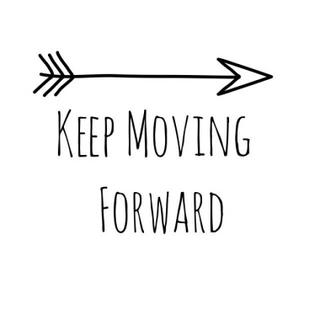.

I exercise my body for the glory of God!

It’s a lifestyle!

**F2F Gold**

Ab Workout Program with direct coaching access, personalized meal plan and detox program

**$125**

**F2F Bronze**

Customized Ab workout program

**$50**

**F2F Silver**

Ab Workout Program with nutrition coaching

**$75**

*14-Day Lifestyle Exercise Program*

Each package is customized according to your fitness level, goals and includes the best ab workouts and core cardio exercises. You will have exercise modules for your abs complete with pictures (and videos available upon request) to tone and tighten your tummy.

Each day of the 14-Day program you will know exactly what to do and if you run into a problem, your coach is just a click or phone call away! You can execute the program one-on-one with me, solo, or you can connect with me via online training.

Whatever the delivery method, I am ***AB-solutely*** committed to helping you get the flat tummy of your dreams!

Coaching for the body, mind and spirit!

Empowering the human endeavor!

I am fit!

anfabulous!

***Holistic Fitness***

### **You have three packages from which to choose to fit your budget.**

Each package includes 4 online training sessions during the

14-Day program.

Page 3

Page 4

*14-Day Lifestyle Exercise Program*

## Testimonials

* 'Awe-inspiring' is the best way to describe training sessions with Eric Croomes! He absolutely gives far beyond the components I needed and wanted in a workout! His approach is effective, time sensitive and challenging. I yielded results through committed sessions with Eric that I was unable to achieve on my own. -Alisha B., Arlington
* Eric is my boot camp instructor. I feel better! My body fat is down! My physical appearance is looking hot! Eric has given me the tools to continue to live a healthy life! Thank you Eric for your motivation and mantras! -M.J., Fort Worth
* Before I started working with Eric I was at 184 lbs. and disgusted with myself. I lacked the motivation to work out and honestly thought I couldn't do it. He helped me get rid of all my excuses and found a way to work around my schedule. In 8 weeks I have lost 20lbs with his nutrition advice and workout regimen. He has given me a new beginning. -Latoya, Dallas
* I was very skeptical at first to start working with a personal trainer. I had just had my second child and was looking for results. I lost 10 pounds on Eric's program and was in the best shape of my life! - -Marquisha Johnson-Williams, Fort Worth

Pay with debit or credit card at [WWW.PASTORWERICCROOMES.COM](http://WWW.PASTORWERICCROOMES.COM)

Click on *“NEW ARRIVAL”,* THEN DOWNLOAD AND COMPLETE THE LIFESTYLE ASSESSMENT



**Or Cash App: $PWECMINISTRIES**

Please feel free to call or text me if you have any questions!

Eric - 214.493.2875

[WWW.PASTORWERICCROOMES.COM](http://WWW.PASTORWERICCROOMES.COM)

**Infinite Strategies Coaching**

**Lifestyle – Wellness - Achievement**

## Let’s Get Started - Choose Your Program and……