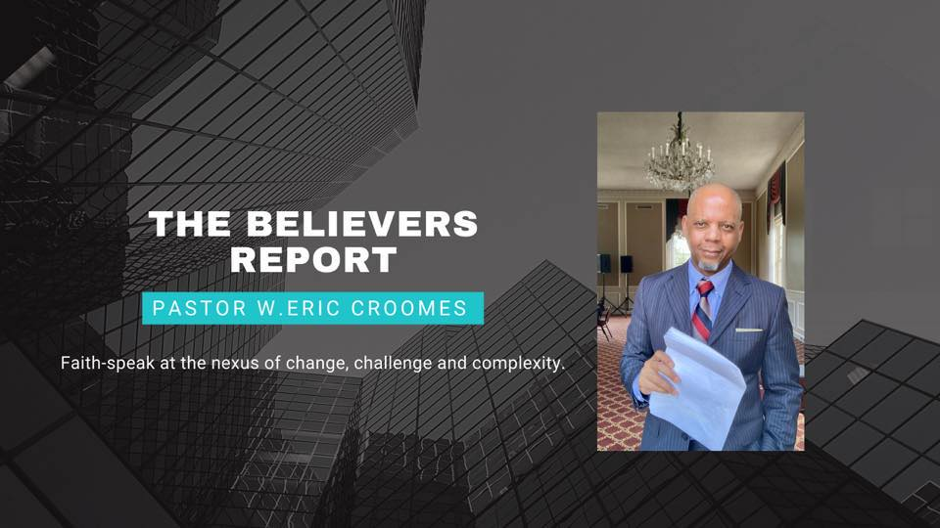
Inspired Living with the Believers Coach, Pastor W. Eric Croomes
Insightful and inspirational faith commentary for spiritual empowerment.
Leadership. Spiritual Empowerment. Wellness.
W. Eric Croomes is a licensed pastor, speaker and certified holistic lifestyle coach who values dedication, service and excellence. As a ministry leader and coach for close to four decades, Pastor “C” brings a unique, holistic perspective to your organization, empowering you to unleash your purpose for a purpose. Using real-world examples and biblical anecdotes, Pastor C unveils how each person in the life of your organization brings a wealth of promise that can be used toward positive results.
A native of Phoenix, Arizona, Pastor C learned the value of dedication and service coming up as the third of six children whose parents, the Reverends Charley and Dorothy Croomes, were themselves exemplar models for ministry. Pastor C founded and is chief executive officer of The Charley and Dorothy Croomes Foundation, launched in his parents’ honor. He is also founder and chief executive coach of Infinite Strategies LLC, a multi-level coaching firm that develops and executes strategies for body, mind and spirit wellness.
Pastor C is author of Watch Your Life: The Believer’s Guide to Thinking, Speaking and Acting Confidently in a Belief-Challenged World and Surge into the New: Stand Up Reach God’s Excellence, a book aimed at helping Christian believers strengthen their faith walk in Christ, written in the middle of a pandemic.
Two of Pastor C’s books, Dance in the Dark, Poetic Reflections on Love and Culture (The Apple Tree Group, 2002) and Brotha2Brotha, Becoming Healthy Men from the Inside Out (The Apple Tree Group, 2006), were nominated in 2007 for a literary award for treatment of relationships, personal achievement and spiritual empowerment.
He is also a contributing writer to ThyBlackMan.Com, the Toledo Journal and to the anthology No Glory Without a Story, released in May, 2010.
The Believers Report with Pastor Croomes offers empowering faith commentary from a male perspective to equip readers and viewers for strong and effective balance in the life of the Spirit.
Pastor C helps believers stay in confidence and go all the way up!
Cell: 214.493.2875
Email: info@pastorwericcroomes.com
Social: PastorWEricCroomesMinistries on Facebook, Twitter, IG and LinkedIn
Web: www.pastorwericcroomes.com
Facebook: Pastor W. Eric Croomes Ministries

Contact me for a list of topics.

