AUGUST 2021/PWEC MIN
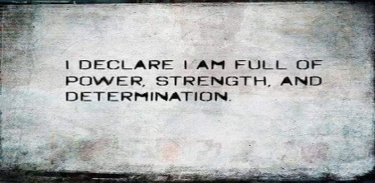

MY BACK TO THE FUTURE PERSONAL MISSION STATEMENT WORKSHEET. COMPLETE HERE ON A SEPARATE PIECE OF PAPER.

MY NAME IS...
- WRITE YOUR FULL NAME

I AM THE SON/DAUGHTER OF...
- WRITE THE NAME OF YOUR FATHER AND MOTHER

I WAS BORN TO...
- DECLARE WHO YOU WERE BORN TO BE (EX: YOUR PROFESSION)
- DECLARE WHAT MISSION YOU WERE BORN TO FULFIL (EX:END HUNGER)
- DECLARE HOW YOU WILL CARRY OUT YOUR MISSION (EX:DETERMINATION)

I AM...
- DECLARE WHICH ATTRIBUTES DEFINE YOU
- WRITE A SCRIPTURE WHICH SUPPORT YOUR IDENITY IN CHRIST

